**KDM Jagadish Tirumalasetty**

**Lab-3 Report #16143014**

**1)**

**Mash up of services- http://jsfiddle.net/jagadish_t/5htbw/43/**

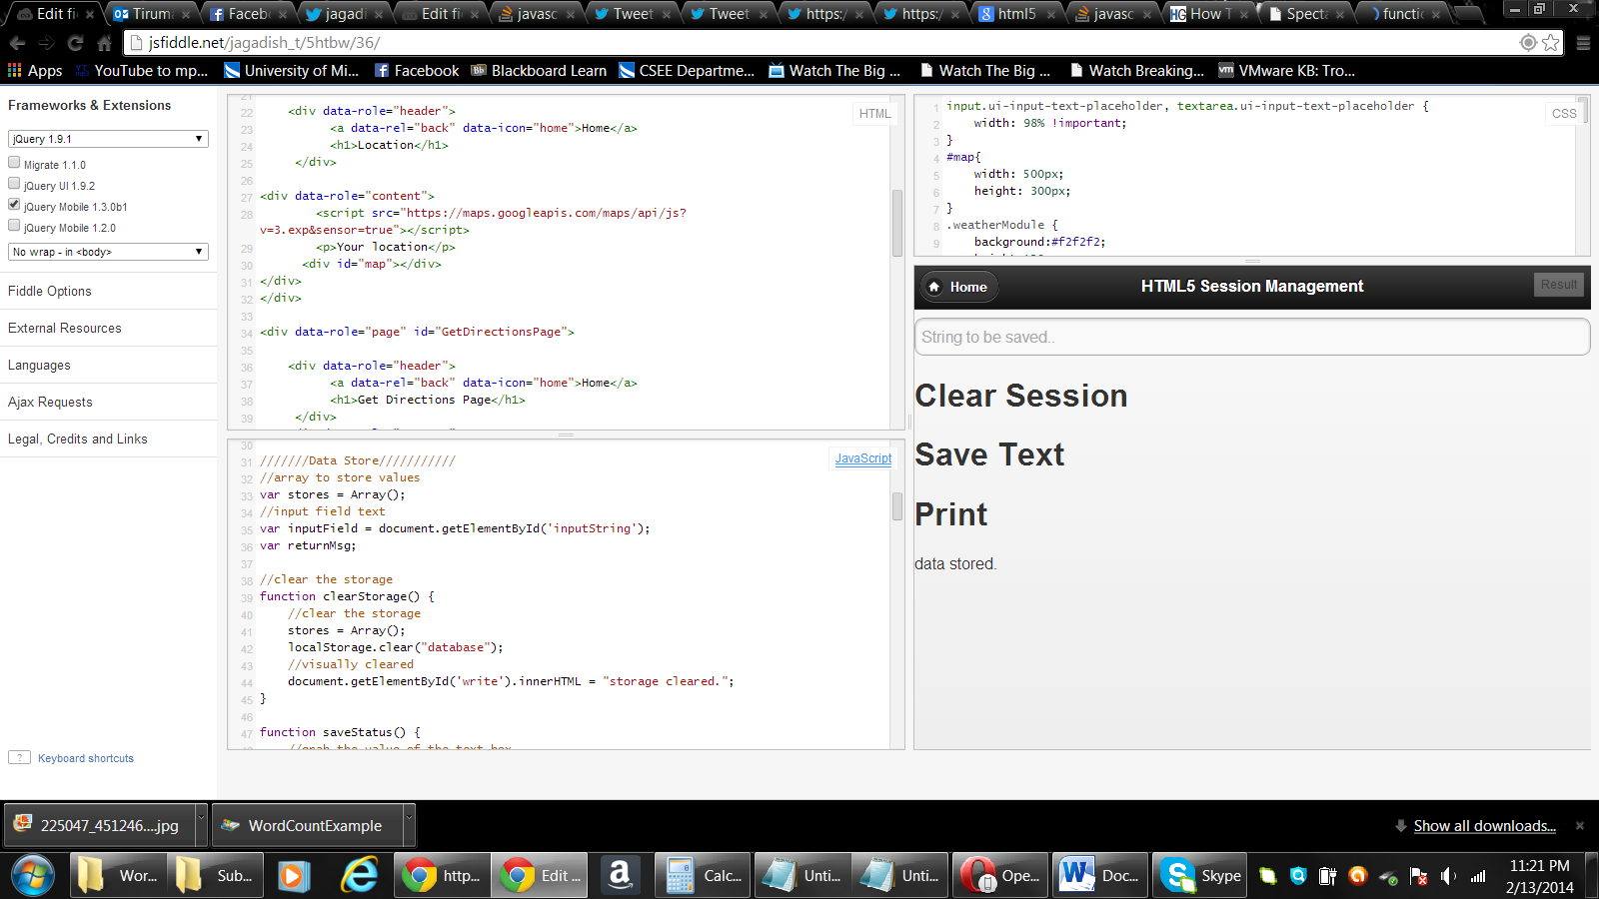

* Home Page – Find the Tweet and Like/Share (FB options)

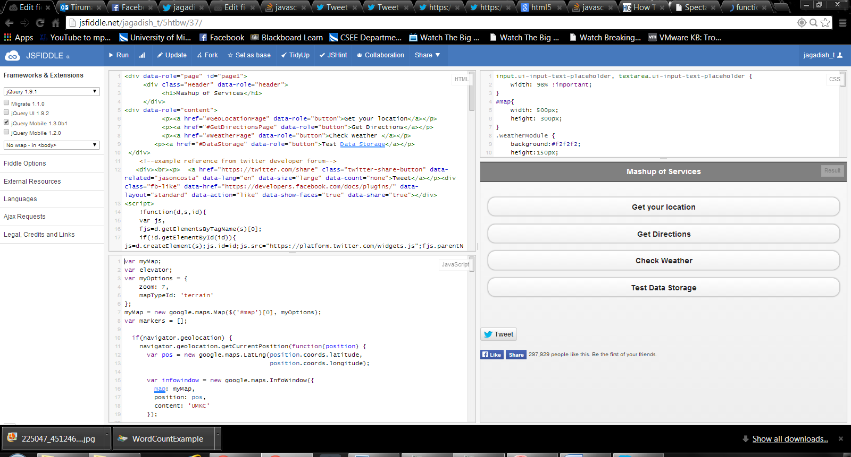

* Upon click of first button – Get your Location below is the screen we navigate to.

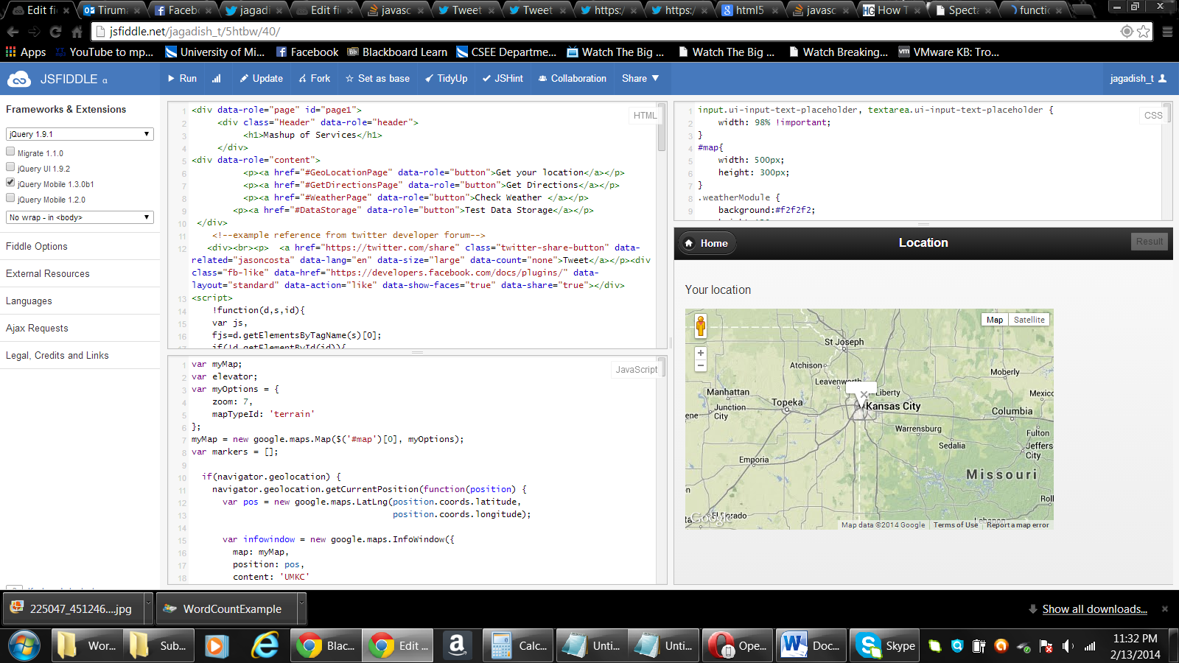

* Upon click of second button – Get direction on home page below is the page we navigate to.

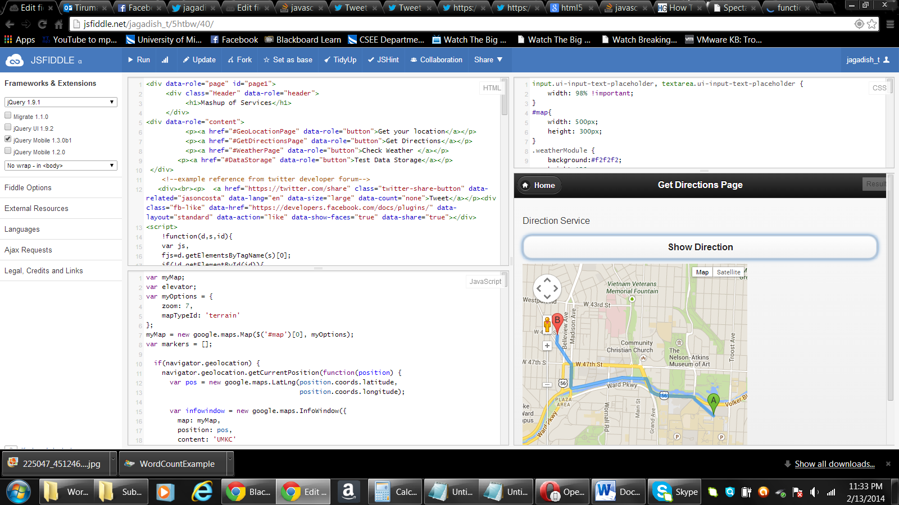

* Below is the Weather info upon selection of Check Weather button on home page

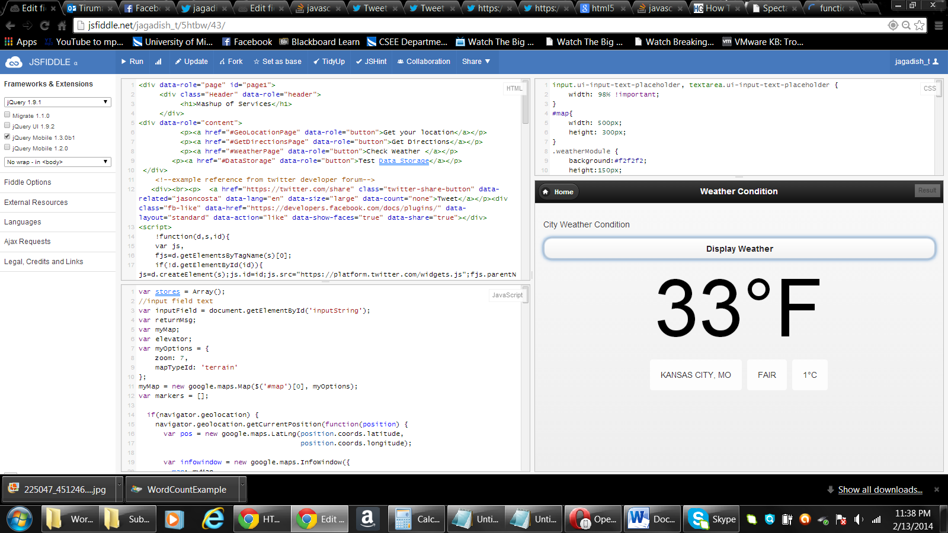

* Upon click of tweet button on home page a pop shares the link on twitter

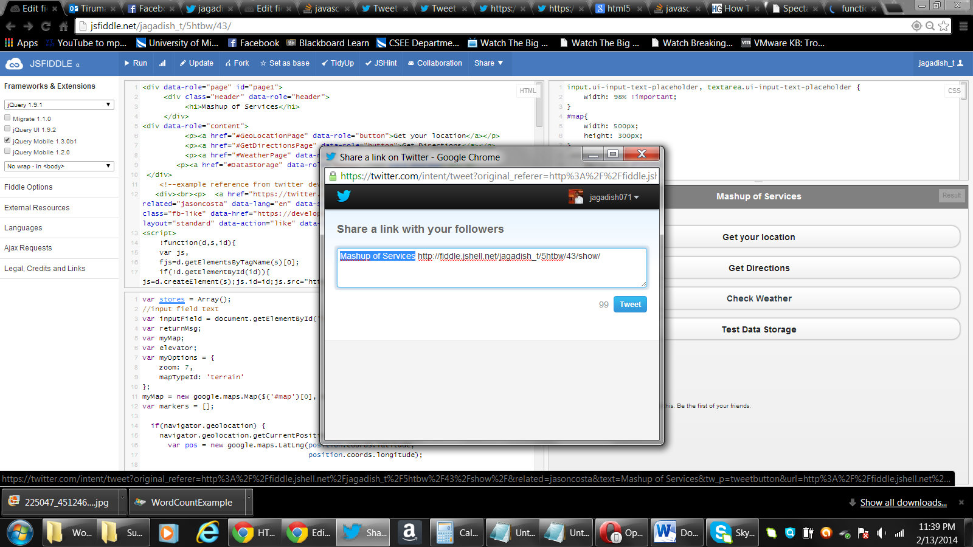

* Upon click of FB share button the plugin FB page is shared on FB.

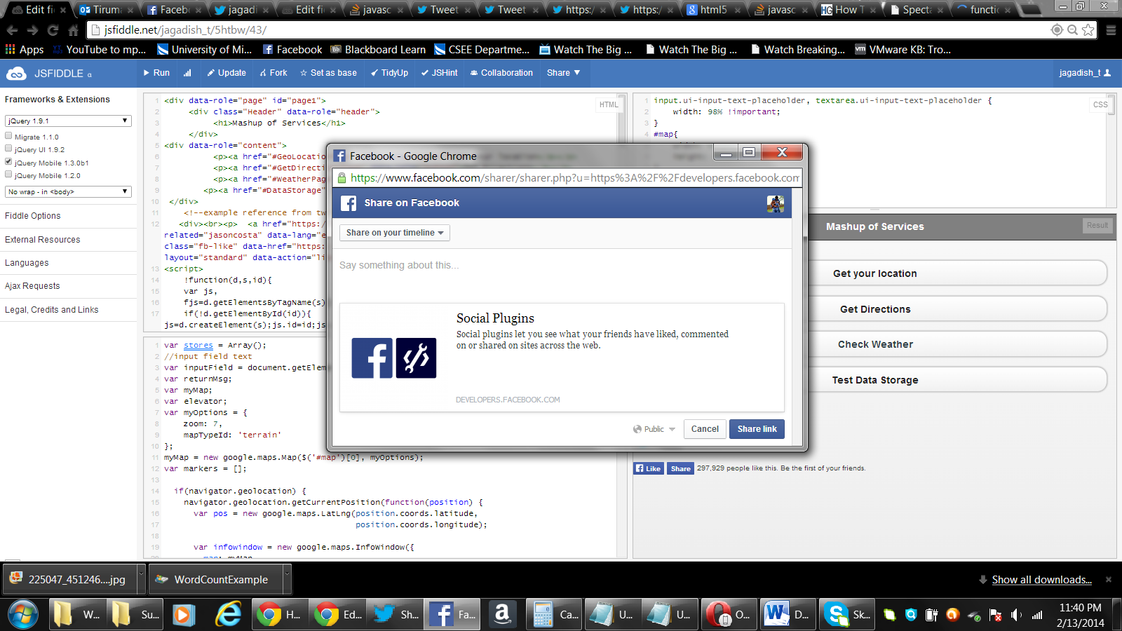

* Data Storage Page

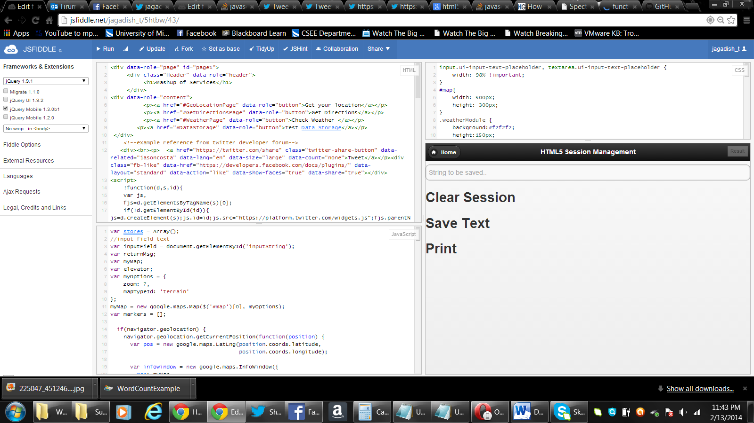

**2) Cloudera/MapReduce:**

* I started with VMware workstation Setup.

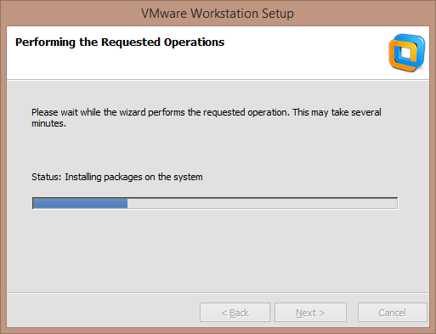

* Then, downloaded the Cloudera from <http://www.cloudera.com/content/support/en/downloads/download-components/download-products.html?productID=F6mO278Rvo>

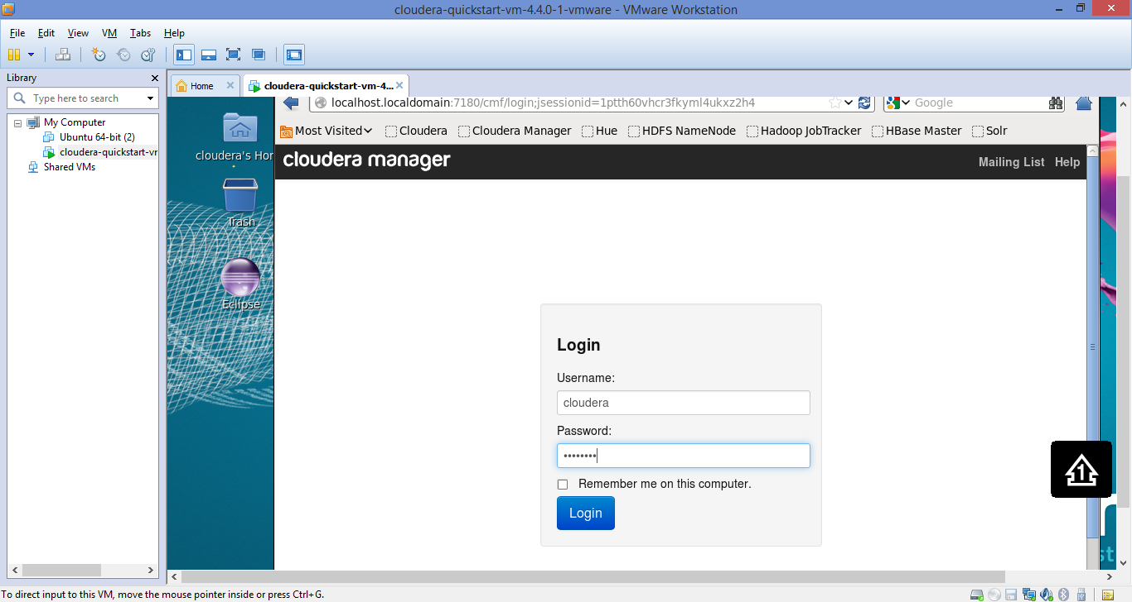

* Downloaded WordCount example source code.

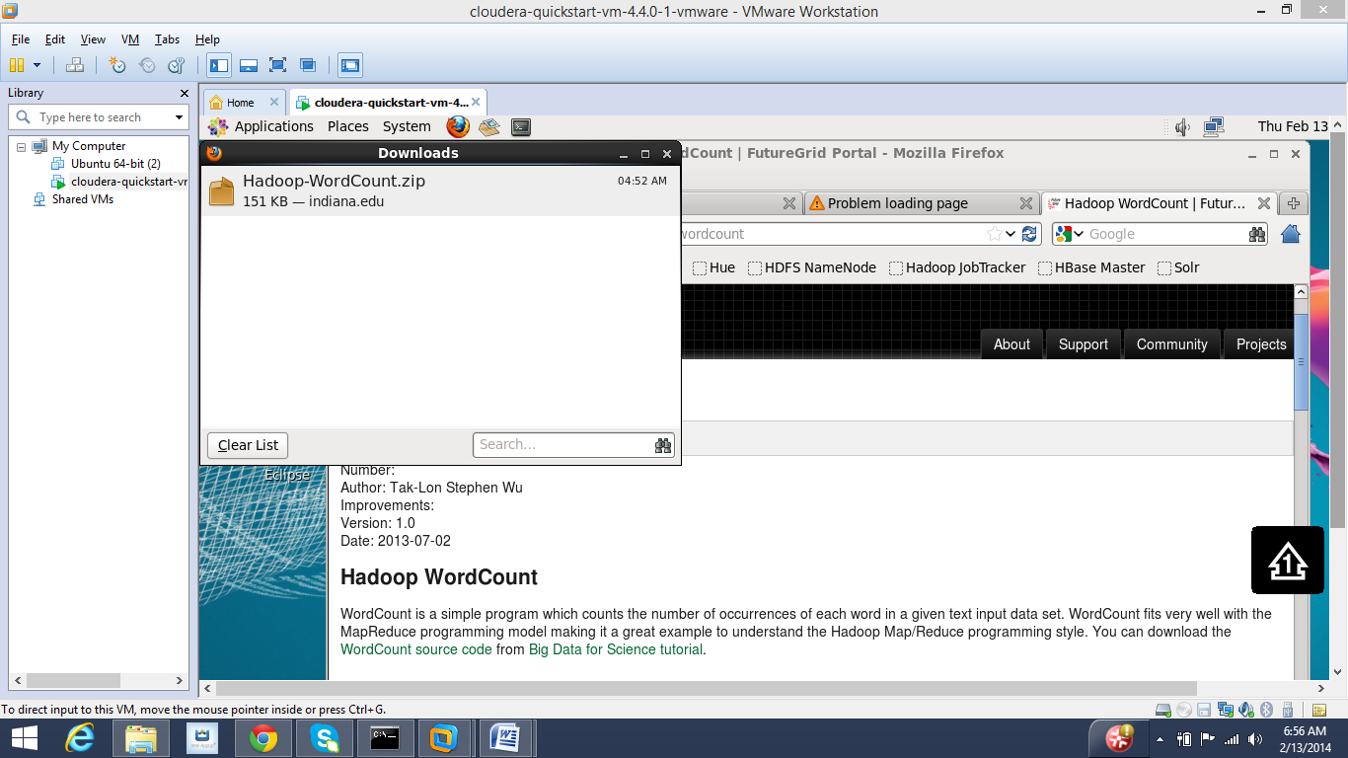

* I then renamed the unzipped folder to WordCount. Then went into to the WordCount directory to move Input directory into Hadoop Input directory using “Hadoop –fs” command.
* Then executed the WordCount.jar file. I have placed the output result as text file on GitHub in the same folder location-LAB3 (named as WordCountExample). The first five lines of below screen shot have captured the same Output.

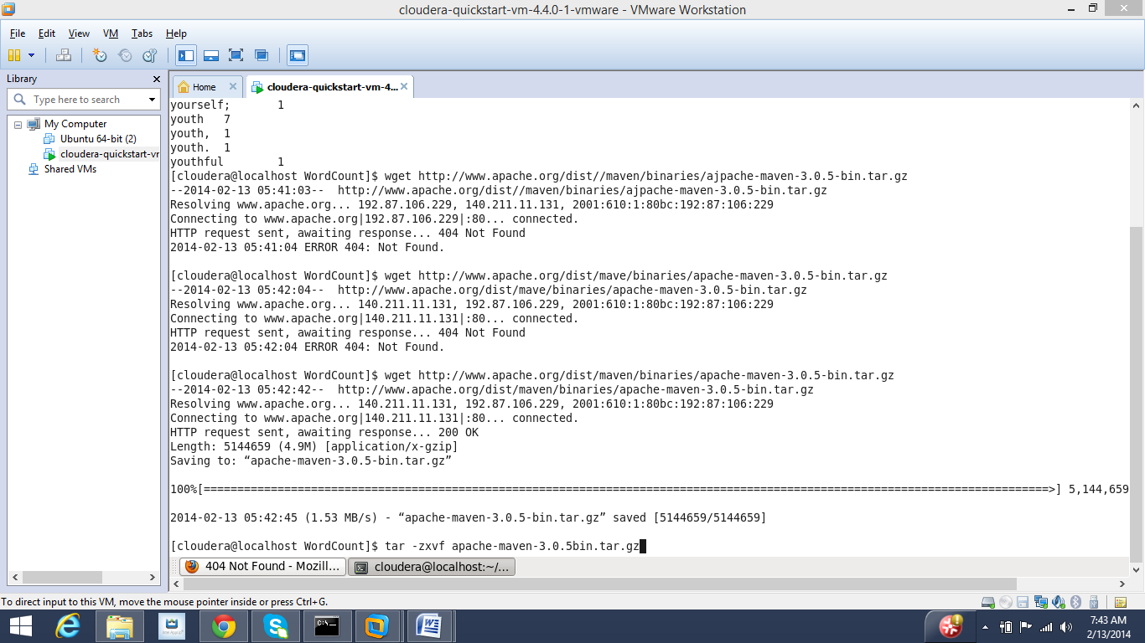

**3) Clouder/Mahout**

* Before proceeding with Mahout, first downloaded maven. Refer screen shots above and below.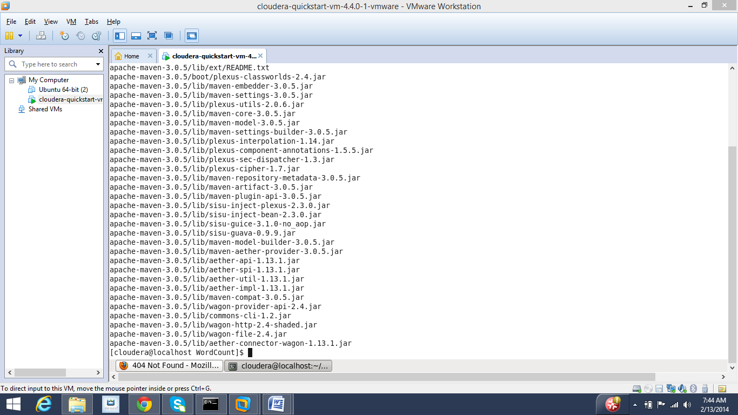
* Created maven path.

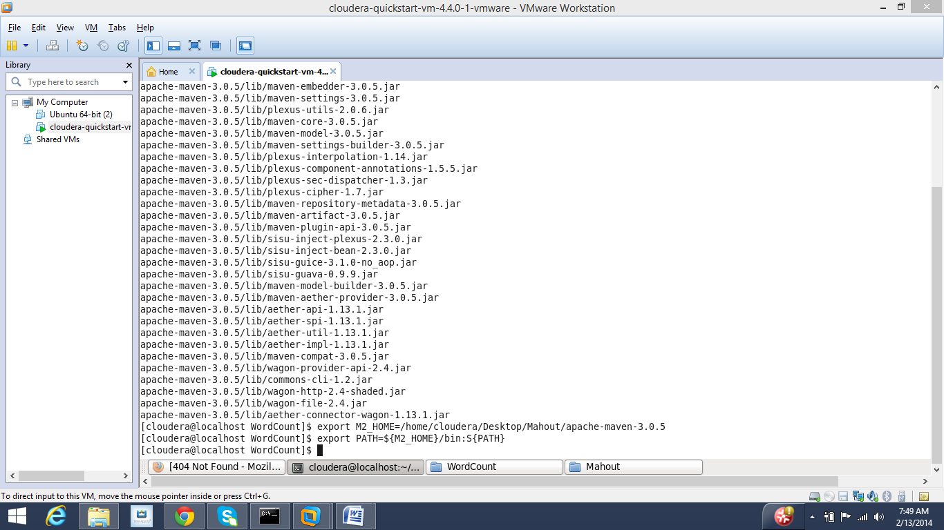

* Then, downloaded Mahout from http://repo2.maven.org/maven2/org/apache/mahout/mahout-distribution/0.6/
* Then, downloaded the pom file and placed it in the same directory as above and installed

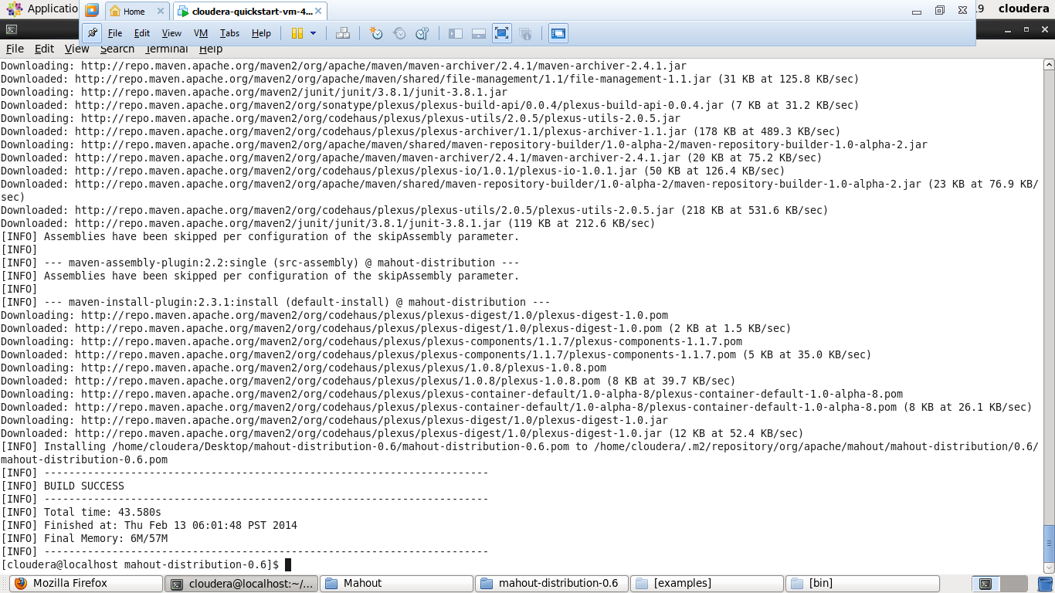

* Executed the classify-20newsgroups.sh file in terminal

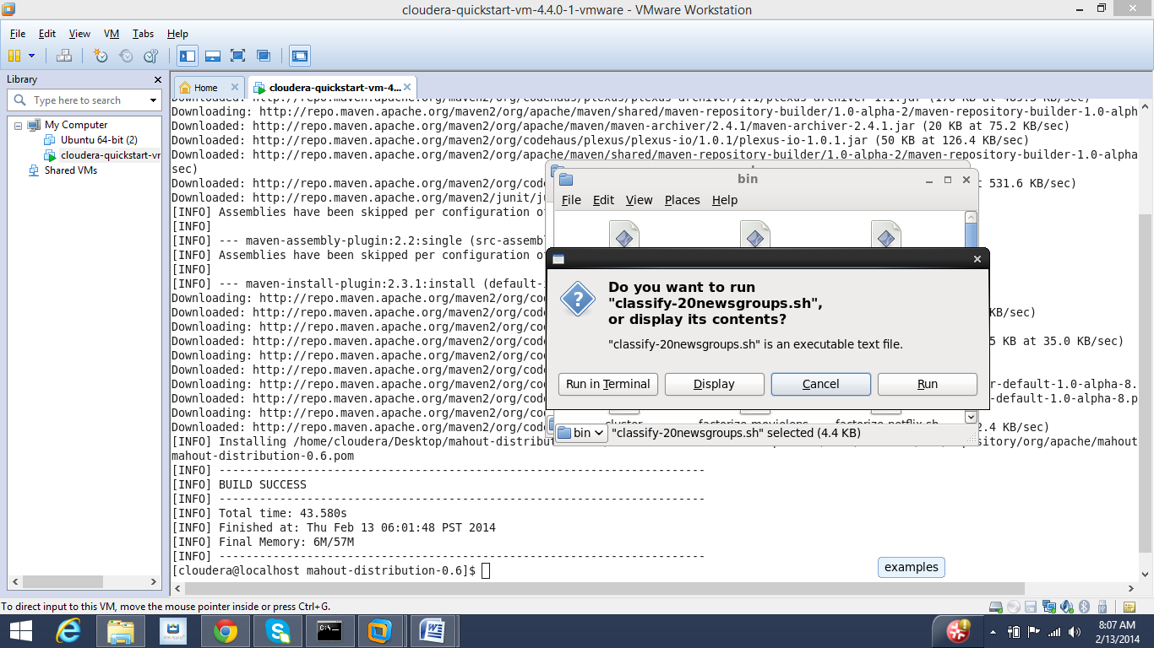

* Upon, execution in terminal selected option 1 for naivebayes classifier.

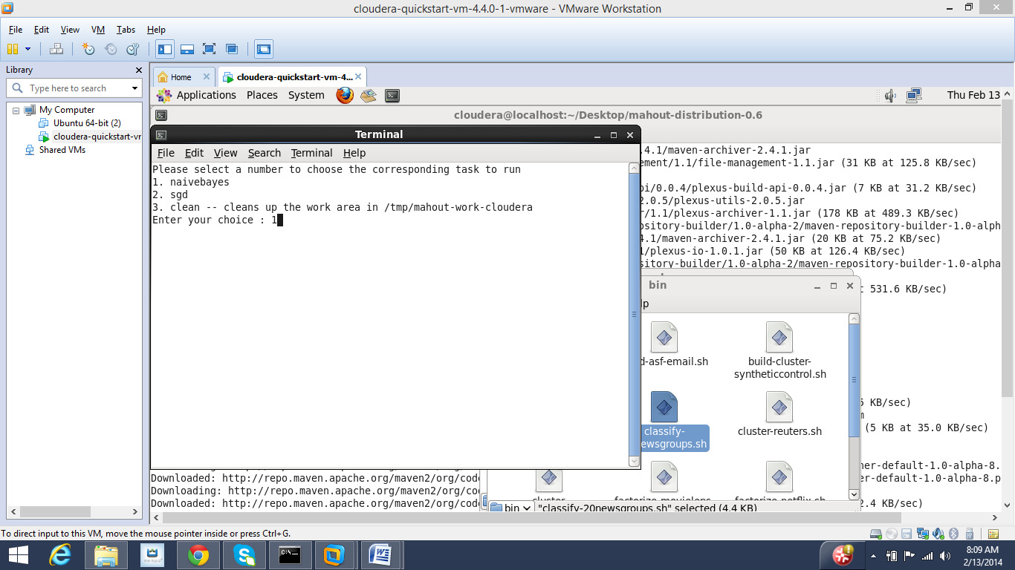

* Below is the screen shot showing execution.

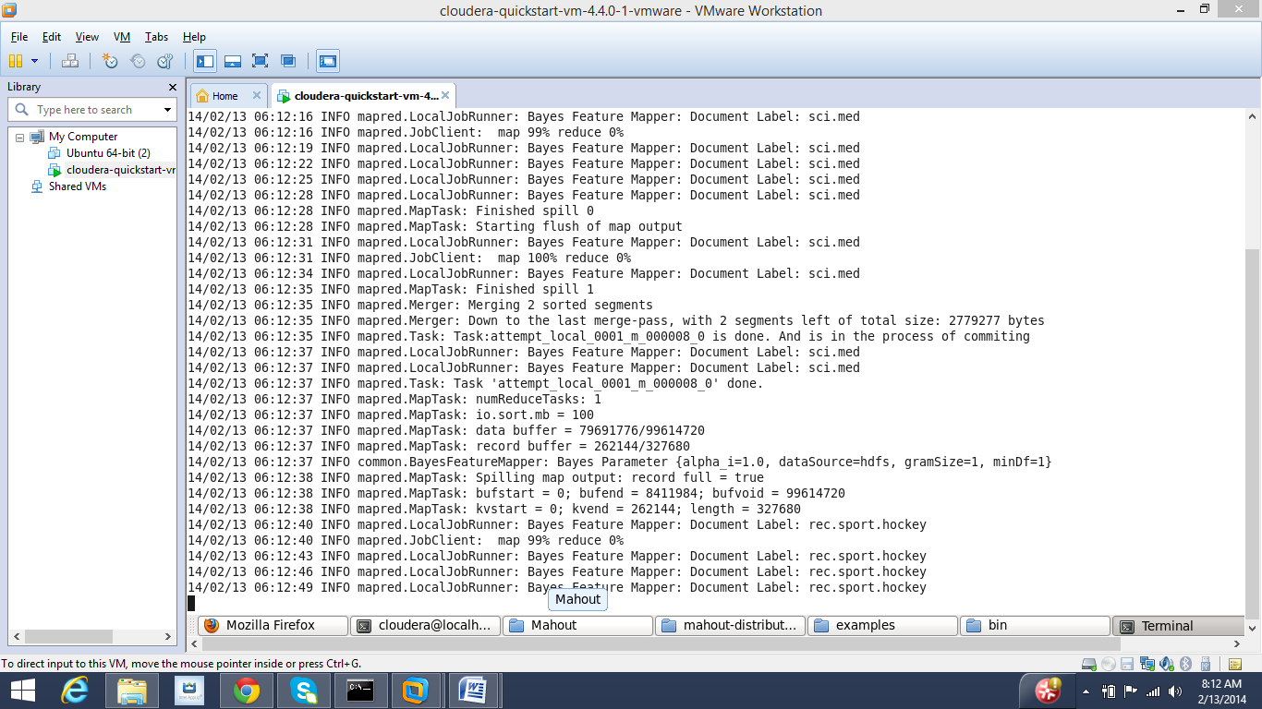

* Selecting Option-2 for sgd optimization

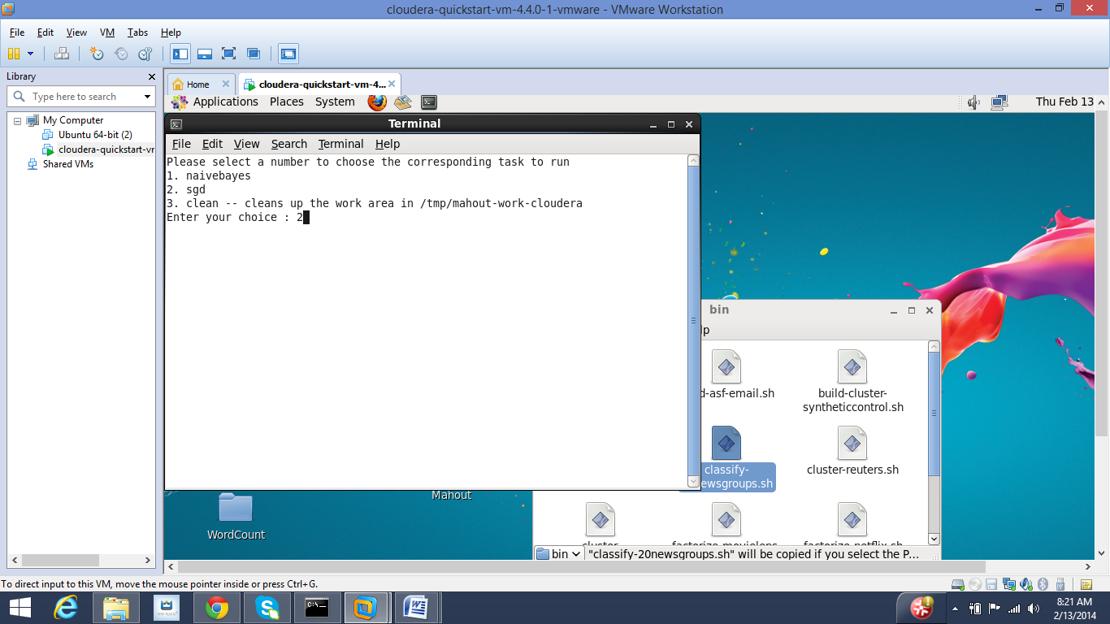

* Execution Result for sgd

